**1.Step-By-Step Guide: Build And Deploy A Simple App Using Jenkins.**

Step 1: In a github, created a repository named as Jenkins and then created a file as Jenkinsfile.

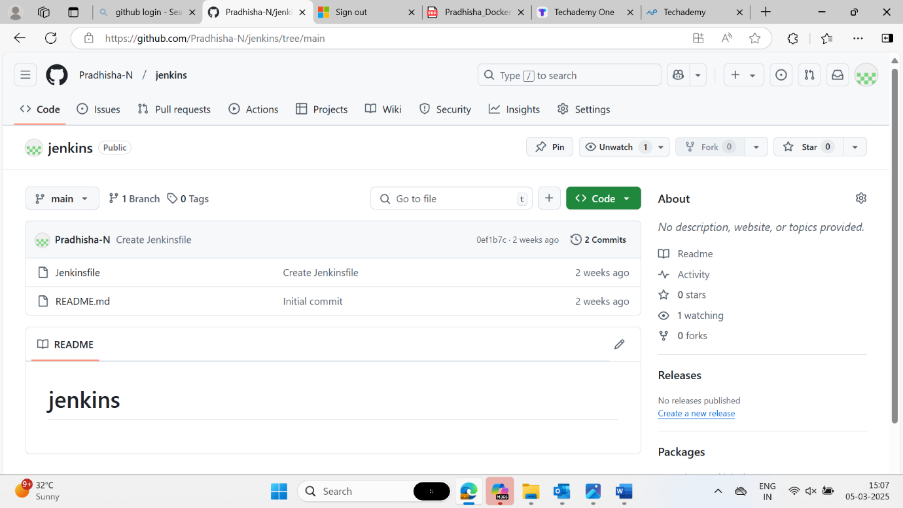

Step 2: Here we are creating a pipeline to run the project.

Step 3: Now save and apply the pipeline.

Step 4: Console output

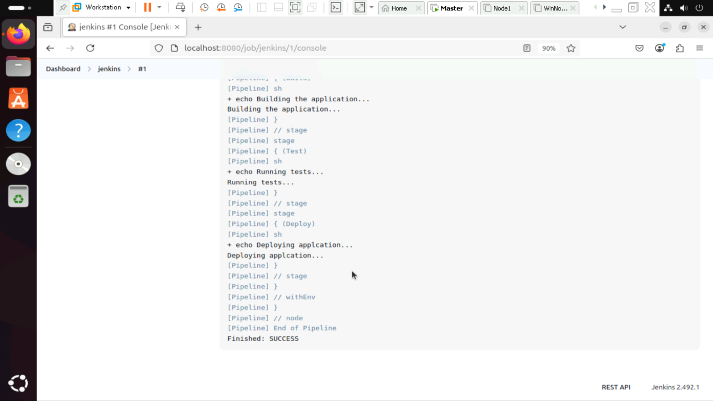

**2. Automating a python application build using Jenkins**

Step 1: In a github, created a repository named as Jenkins and then created a file as python-app

Step 2: In a github, created a repository named as Jenkins and then created a file as first.py

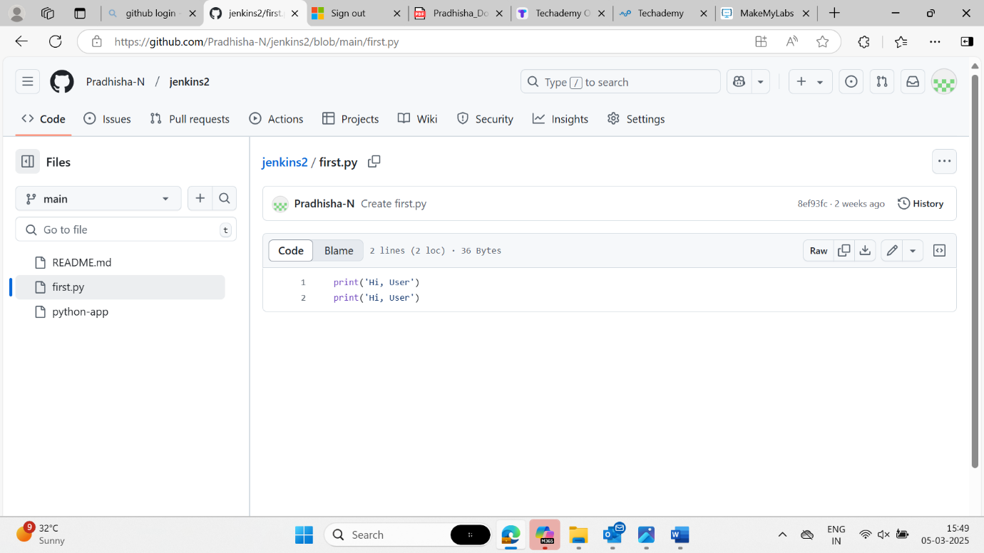

Step 3: Here we are creating a pipeline to run the project.

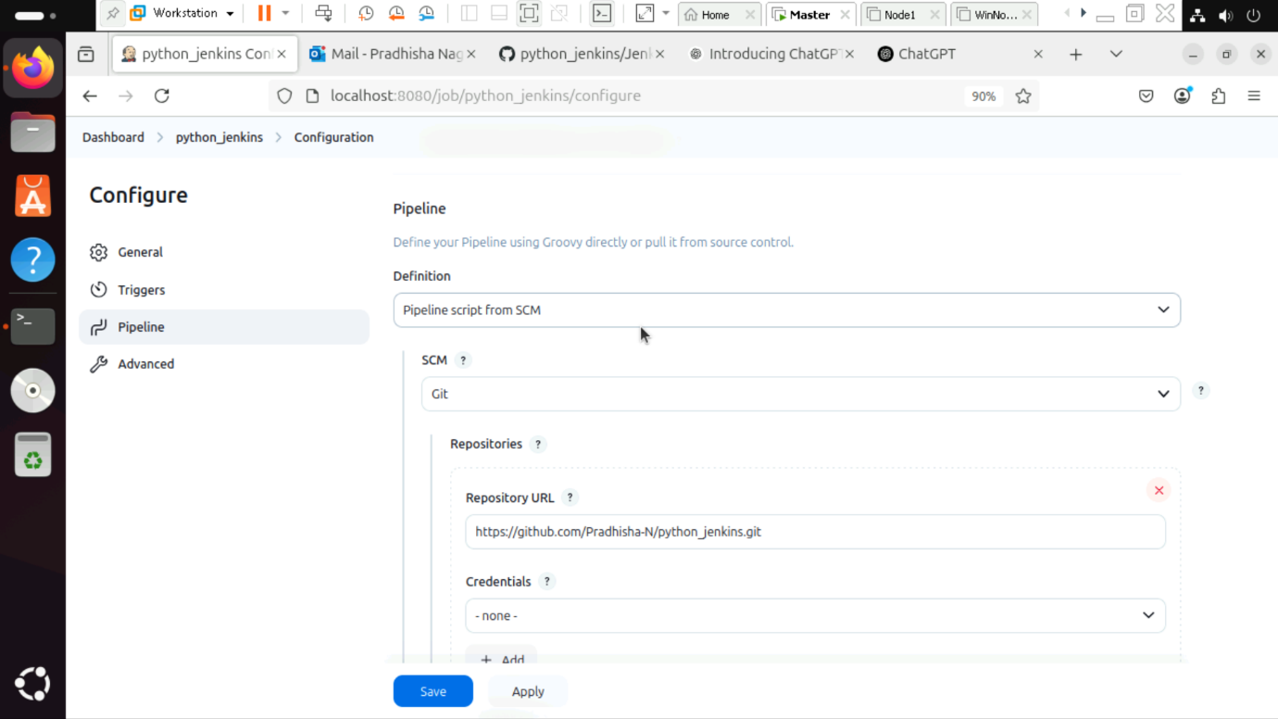

Step 4: Now save and apply the pipeline.

Step 5: Console output

